**Machine Learning Approach for Crypto Currency Price Prediction**

Anitha Julian  
*Department of Computer Science and Engineering*  
*Saveetha Engineering College*

Chennai, India

cse.anithajulian@gmail.com

ORCID ID <https://orcid.org/0000-0002-8684-6220>

K Vamshi Krishna

*Department of Computer Science and Engineering  
Saveetha Engineering College*

Chennai, India

vk5607225@gmail.com

B Sampath Kumar Rao  
*Department of Computer Science and Engineering*

*Saveetha Engineering College*

Chennai, India

bangalesampathkumarrao@gmail.com

K Yogendra Reddy

*Department of Computer Science and Engineering  
Saveetha Engineering College*

Chennai, India

yogendrakarnati777@gmail.com

*Abstract*—- Investments are one of the major sources of income in one's life. The usual question that arises is to which category one should invest in. In the market there are many investment options such as stocks, cryptocurrencies and mutual funds, but everyone who wants to invest normally expect high returns as well as security. That is what crypto currency does, as the future is not just money, but many processes and operations that power our day-to-day lives. The proposed work uses machine learning algorithms for predicting the Crypto Currency price. A linear regression model is used to train the machine learning model with maximum efficiency and the model is implemented to predict Crypto Currency price. The model has been trained with a dataset containing the Crypto Currency exchanges which were provided by the user for the time with minute-by-minute updates of OHLC (Open, High, Low, Close), volume in respective Crypto Currency and indicated currency, and weighted Crypto Currency price. The proposed regression algorithm identifies with reasonable accuracy.

Keywords — Streamlit, Fb Prophet, Crypto Currency, Prediction.

# Introduction

The world's economy is today dominated by the business and finance sector. Crypto currency trading is a major international practice in the finance sector. Financial exchange predictions are always trickier when it comes to Cryptocurrency price predictions. The goal of this technique is to predict the future value of a crypto currency coin to avoid loss or gain profit. The proposed work demonstrates a machine learning approach to predict the same. To make near-effective predictions, a machine learning algorithm that can be trained by analysing the past datasets of some companies is used. Several analysts disagree with the accuracy of predictions based on the efficient market hypothesis. They argue that these predictions cannot be made on the available data, therefore deeming these outcomes to be inherently unpredictable. But there are numerous tools and technologies that help to gain future trend insight, resulting in effective profits. The reason many investors are keeping their distance from the stock market is the high return on investment of crypto currency. Bitcoin is not the only coin that stands to gain profits, many more are as well.

# Literature Survey

An artificial intelligence system that uses past data to predict the future is known as machine learning (ML). There are several advantages to using machine learning-based forecasting models, especially in time series, as prior research has shown that they produce results that are nearly or exactly the same as the actual results, and they also improve their accuracy. Fbprophet, owned by Facebook Prophet, and additive linear regression are examples of machine learning.

As illustrated in [8], cryptocurrency can improve the effectiveness of a portfolio in two ways. In the first case, investors would be provided with more allocation options, and in the second case, the standard deviation would be reduced. Depending on the investor's risk tolerance, the best cryptocurrency allocation is between 5% and 20%. In [8], the authors focus on time series data forecasting in particular and apply two machine learning algorithms, random forests (RF) and stochastic gradient boosting machines (SGBM). As a result of the research, it has been demonstrated that the ML ensemble technique can be used to predict Bitcoin values.

# Related Work

Crypto Currency Price Prediction is a popular yet challenging task. The proposed work can predict the price before deciding whether to buy or sell. This enables the user to easily invest in crypto currencies with it. Currently, the business and financial sector dominates the global economy. Crypto currency investing is a major practice in the finance sector.

As financial institutions adopt AI, machine learning is increasingly used to help make investment decisions. Although there is an abundance of stock data for machine learning models to train on, high noise to signal ratios, as well as the multitude of factors that affect crypto prices, make it difficult to predict the market. At the same time, these models do not need to reach high levels of accuracy because even 60% accuracy can deliver solid returns. One method for predicting crypto prices uses Prophet algorithm for times series forecasting and enables to identify and track the patterns that trigger its dynamic movement.

Prophet is an improved version of Facebook Prophet. The Prophet library developed by Facebook is a popular library that is used specifically for forecasting time series data. Based on their website, it is an [additive regression model](https://en.wikipedia.org/wiki/Additive_model) with four main components namely,

* A curve for detecting changes in trends of the variable for which forecast is to be made by picking variation-points from the time-series data.
* A yearly seasonal component (uses Fourier series)
* A weekly seasonal component
* A customizable list representing holiday effects in the data

Cryptocurrency price, like stock price, is a time series data and hence justified for the use of Prophet algorithm for analysis in the proposed work.

# Methodology

Cryptocurrency price prediction seems a complex problem because there are many factors that have yet to be addressed and it does not seem statistical initially. But by proper use of machine learning techniques, one can relate previous data to the current data and train the machine to learn from it and make appropriate assumptions.

Fig. 1**.** System Architecture.

Figure 1 shows the system architecture. This is the fundamental module of the proposed work. The dataset is a group of data that are mended together to show the data variations in a time span to undergo further estimation and the source of the resources and its outcome for the later time of evaluation. It generates the result optimization and gives a feasible time period to customize and get the flow to the derivation. Results are generated in each phase of testing. This is also termed as the testing phase. Now a new set of datasets are passed which are deliberately like the training dataset and the efficiency of the same is calculated.

It is possible to predict the future price of this crypto currency based on the past data of the currency and the current price of the currency. Modeling the input data and the target data generated using machine learning followed by regression is done based on the input data and the target data generated.

*A. YFinance*

It is a python package that enables us to fetch historical market data from Yahoo Finance API in a Pythonic way. It becomes very easy for all the Python developers to get data with the help of this module.

*B. FB Prophet*

It is a powerful time series analysis package released by Core Data Science Team at Facebook. It is simple and easy to go package for performing time series analytics andforecasting at scale.

The table 1 shows the different features in the dataset, which can be used to predict currency prices. The prediction relies on six purely necessary features, which were extracted from Yahoo Finance. Depending on the input (the user will be offered to select the crypto currency that they wish to predict), these datasets will be modified. As a result, the input data will be used to extract the dataset from the yahoo finance.

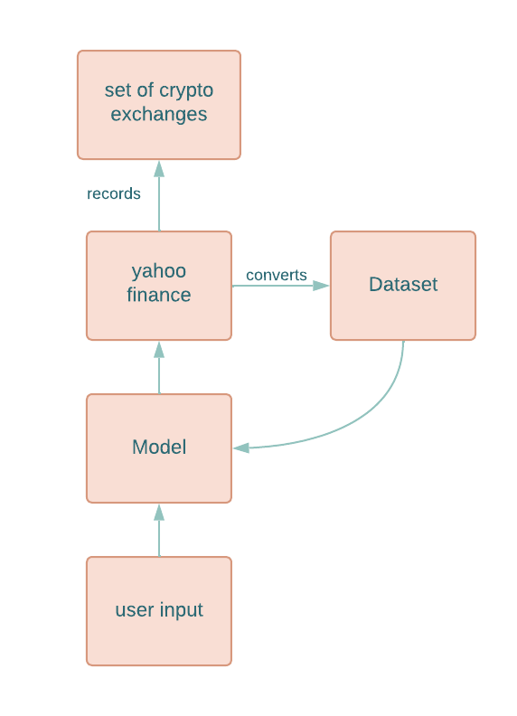

Fig. 2. Obtaining Datasets

|  |  |
| --- | --- |
| **DATA SET HEADER** | **EXPLANATION** |
| Open | The header on one of them is "open". Open means the price at which a stock started trading when the opening bell rang. |
| High | The high is the highest price at which a stock traded during a period. |
| Low | The low is the lowest price of the period. A stock's high and low points for the day are often called it's intraday high and low. |
| Close | Close refers to the price of an individual stock when the stock exchange closed shop for the day. It represents the last buy-sell order executed between two traders. In many cases, this occurs in the final seconds of the trading day |
| Adj Close | The adjusted closing price amends a coin's closing price to reflect that coin's value after accounting for any corporate actions. It is often used when examining historical returns or doing a detailed analysis of past performance. |
| Volume | Volume is the total number of coins traded in a security over a period. Every time buyers and sellers exchange shares, the amount gets added to the period's total volume. |

Table 1. Dataset parameters with explanation

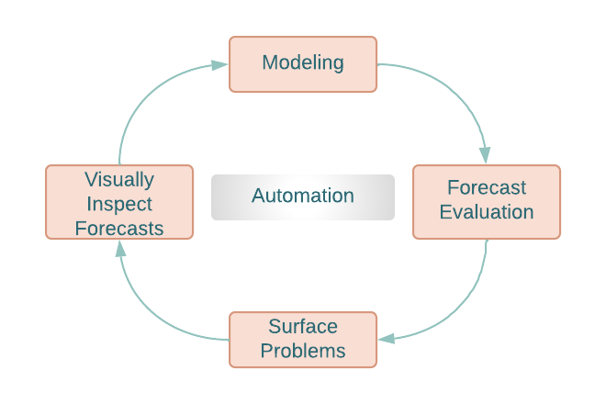

Fig. 3. Work Flow

*C. Streamlit*

It is an open-source Python library that makes it easy to create and share beautiful, custom web apps for machine learning and data science. In just a few minutes you can build and deploy powerful data apps.

*D. Working of prophet model*

Essentially, Prophet is an additive regression model with four main components.

* Growth curves shaped piecewise linearly or logistically. A selection of changepoints from the data is used by Prophet to automatically detect changes in trends.
* Using Fourier series, we model a seasonal component modeled using Fourier series.
* We use dummy variables for the weekly season.
* User-supplied holidays are considered.

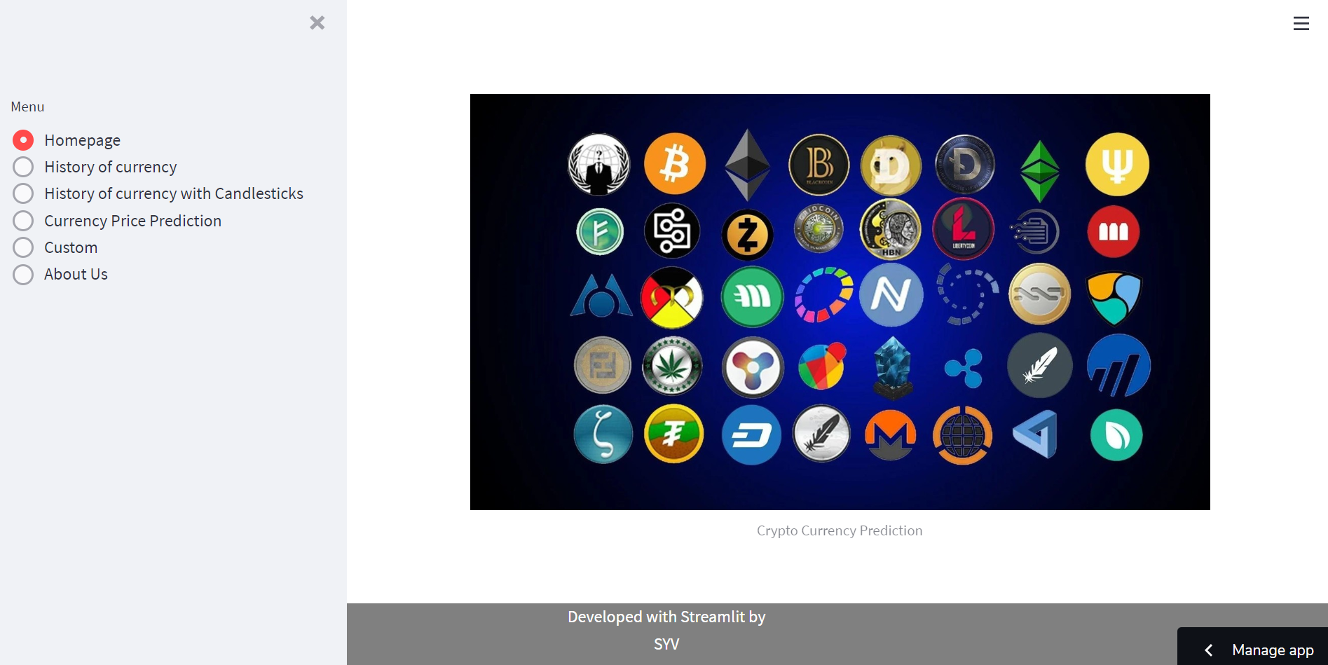

Fig. 4. Dashboard

Figure 4 shows the site's homepage after a user has been redirected.

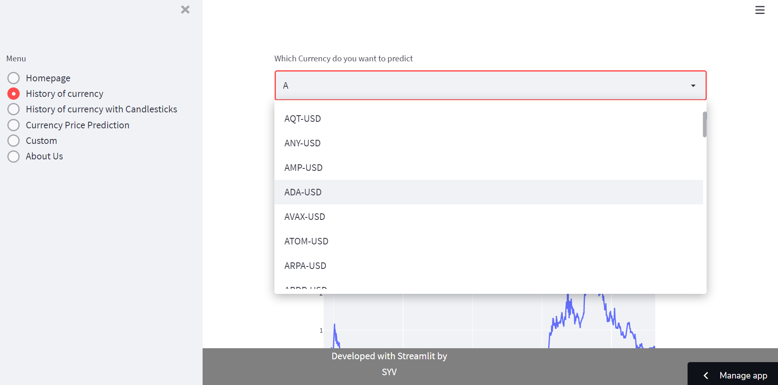

Fig. 5. Selecting Crypto Currency

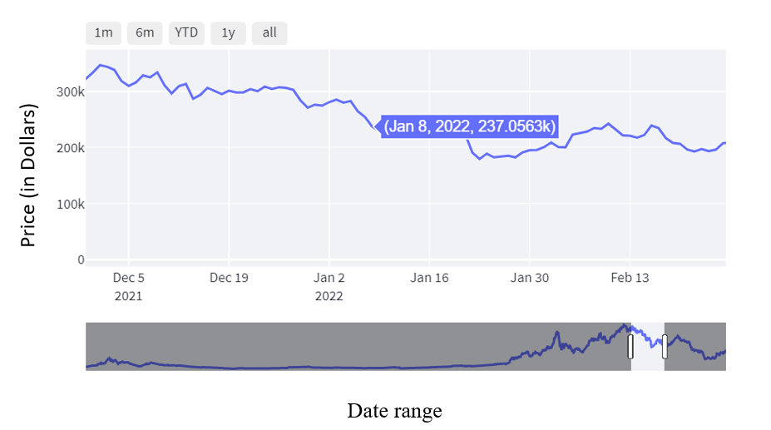

Fig. 6.History of selected crypto currency.

For example, if user selects Ethereum as to be predicted, then the above graph states that the history of Ethereum coin.

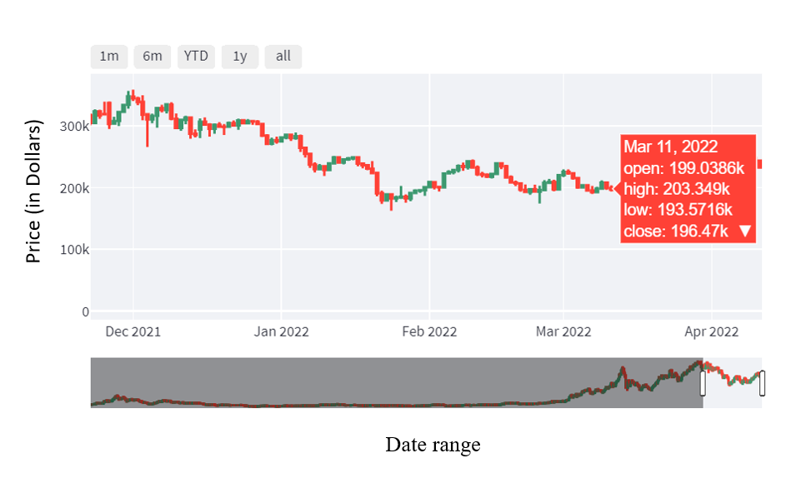

Fig. 7**.** History of selected crypto currency with candlesticks.

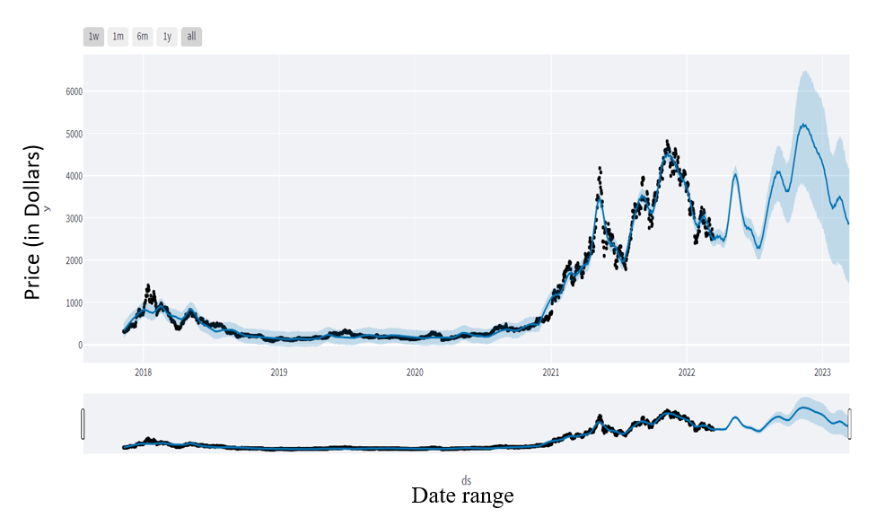

Fig. 8.Selected crypto currency Price Prediction.

The black spots (dots) in Figure 8 indicate the actual prices of the Ethereum coin. The consistent blue line represents the predicted price of the Ethereum coin.

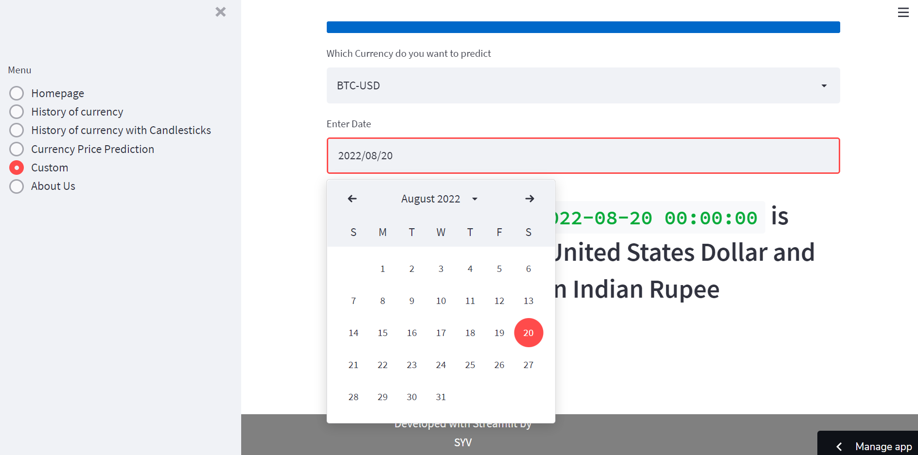

Fig. 9. Getting date as input to return price.

      In Figure 9, the user can choose a particular date to get the price.

# PERFORMANCE METRICS

The R-squared error is the metric used to evaluate the performance of the proposed algorithm. This represents "the fraction of variance of the actual response variable captured by the regression model". The R-squared error indicates the variance between the actual value and the predicted value. Ideally, model quality will be determined by R-squared error, which is of the greatest value.

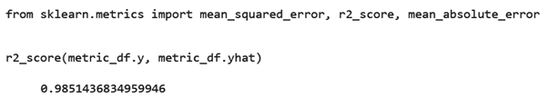

Fig. 10. R - Squared Error computation.

As the integration of the same is higher with other dependencies so leaving dependencies compromise the level of accuracy. Accuracy is not the term used over in stock as the actual prediction is not possible for any fiscal days it keeps on changing and turning the tables day and night. Having higher component assets and the dependencies makes it more feasible and flexible in nature causing it even harder to predict. The approximate values are taken into consideration and the hit or profit, or the gain rate is calculated for the same.

# Conclusion and future work

To conclude crypto is an unpredictable mechanism which follows the segments of chain and the dependencies of the same are unpredictable. It is defined to be a curve which keeps on changing and turning the price from low to high and vice-versa.

As the prices in this dataset were inconsistent, i.e., they were taken from the Yahoo official website, which will update from time to time, the prices will continue to fluctuate. Therefore, there is no need to manually update price.

The proposed software takes the raw set of data from the Yahoo finance library and process it. The cleaning of data are done and then further processed to gain the effective outcomes. After the computations the output is displayed in the screen in the form of graph and gives the price of Crypto Currency on desired date also.

In the process of prediction various high level machine learning algorithms are implemented and integrated. The output is generated from the same making a visualized outputs in the form of graph which makes it easier for users to understand and interpret what’s the scenario and they can decide on the same to invest and get the benefit out of it.

A future version of this project will be developed to include more features for feasibility and provide a better idea of crypto currency in general.

‘The authors do not promote or suggest that the reader to buy crypto currency. In the research that was conducted on graphs related to crypto currency, it has been found that there are consequences in the real world that our machines cannot cope with, such as emotional intelligence that may affect prices which tends to not give accurate predictions (This is significantly applicable during pandemic situations).’

##### References

1. coindesk.com It is an independent operating subsidiary of Digital Currency Group, which invests in cryptocurrencies and blockchain startups.
2. coinbase.com It is a secure online platform for buying, selling, transferring, and storing digital currency. It is a Cryptocurrency exchange platform.
3. docs.streamlit.io Streamlit library includes our Get started guide, API reference, and more advanced features of the core library including caching, theming, and Streamlit Components.
4. Streamlit Community Cloud is an open and free platform for the community to deploy, discover, and share Streamlit apps and code with each other. Create a new app, share it with the community, get feedback, iterate quickly with live code updates, and have an impact!
5. Towardsdatascience.com for Streamlit hands on experience.
6. finance.yahoo.com Crypto Currency Fluctuations.
7. Mohammad Hamayel, Amani Yousef Owda, A Novel Cryptocurrency Price Prediction Model Using GRU, LSTM and bi-LSTM Machine Learning Algorithms. [[*Reference*](https://www.researchgate.net/publication/355202227_A_Novel_Cryptocurrency_Price_Prediction_Model_Using_GRU_LSTM_and_bi-LSTM_Machine_Learning_Algorithms)*]*
8. Derbentsev, V.; Babenko, V.; Khrustalev, K.; Obruch, H.; Khrustalova, S. Comparative Performance of Machine Learning Ensemble Algorithms for Forecasting Cryptocurrency Prices. [[*Reference*](https://www.ije.ir/article_122162.html)]